**IRRIGATOR SOFTWARE**

**V 2.0**

**INTERFACE GUIDE**

**Table of contents**

Contents

Requirements: 3

Requirements for hosting: 3

Interface guide 4

Irrigator application section 4

Status section 4

Real time data section 5

Set process section 6

# Requirements:

* **Internet Connection**
* **Device with a browser (Mobile, Laptop, PC)**

**Interface is a single web browser page that includes html, css, javascript files.**

**Server: localhost, development server written under Django framework.**

# Requirements for hosting:

* **Bootstrap 3+**
* **Jquery 3.0 +**
* **Django framework**

# Interface guide

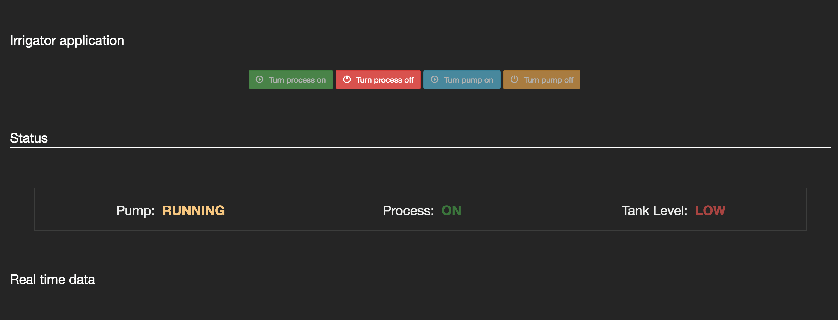

Irrigator application section **– contains 4 buttons:**

1. **Turn process on – this button turns the process on and enables sensor reading the info and process it.**
2. **Turns process off – this button turns the process of and disables sensor reading and info process.**
3. **Turn pump on – this button sends a signal to turn the pump on (only available in manual mode)**
4. **Turn pump off – this button sends a signal to turn the pump off (only available in manual mode)**

**Buttons 1) , 2) are mutually exclusive. This means that only one button is active at a time and clickable. Buttons 3), 4) are also mutually exclusive.**

Status section **– contains 3 parameters:**

1. **Pump: displays “RUNNING” if the pump is on or “OFF” if the pump is off.**
2. **Power: displays “ON” if power is turned on and “OFF” if power is turned off.**
3. **Tank Level: displays LOW if tank level is under 20% (under 1 litre of water) and “OK” if the tank level is over 20%.**

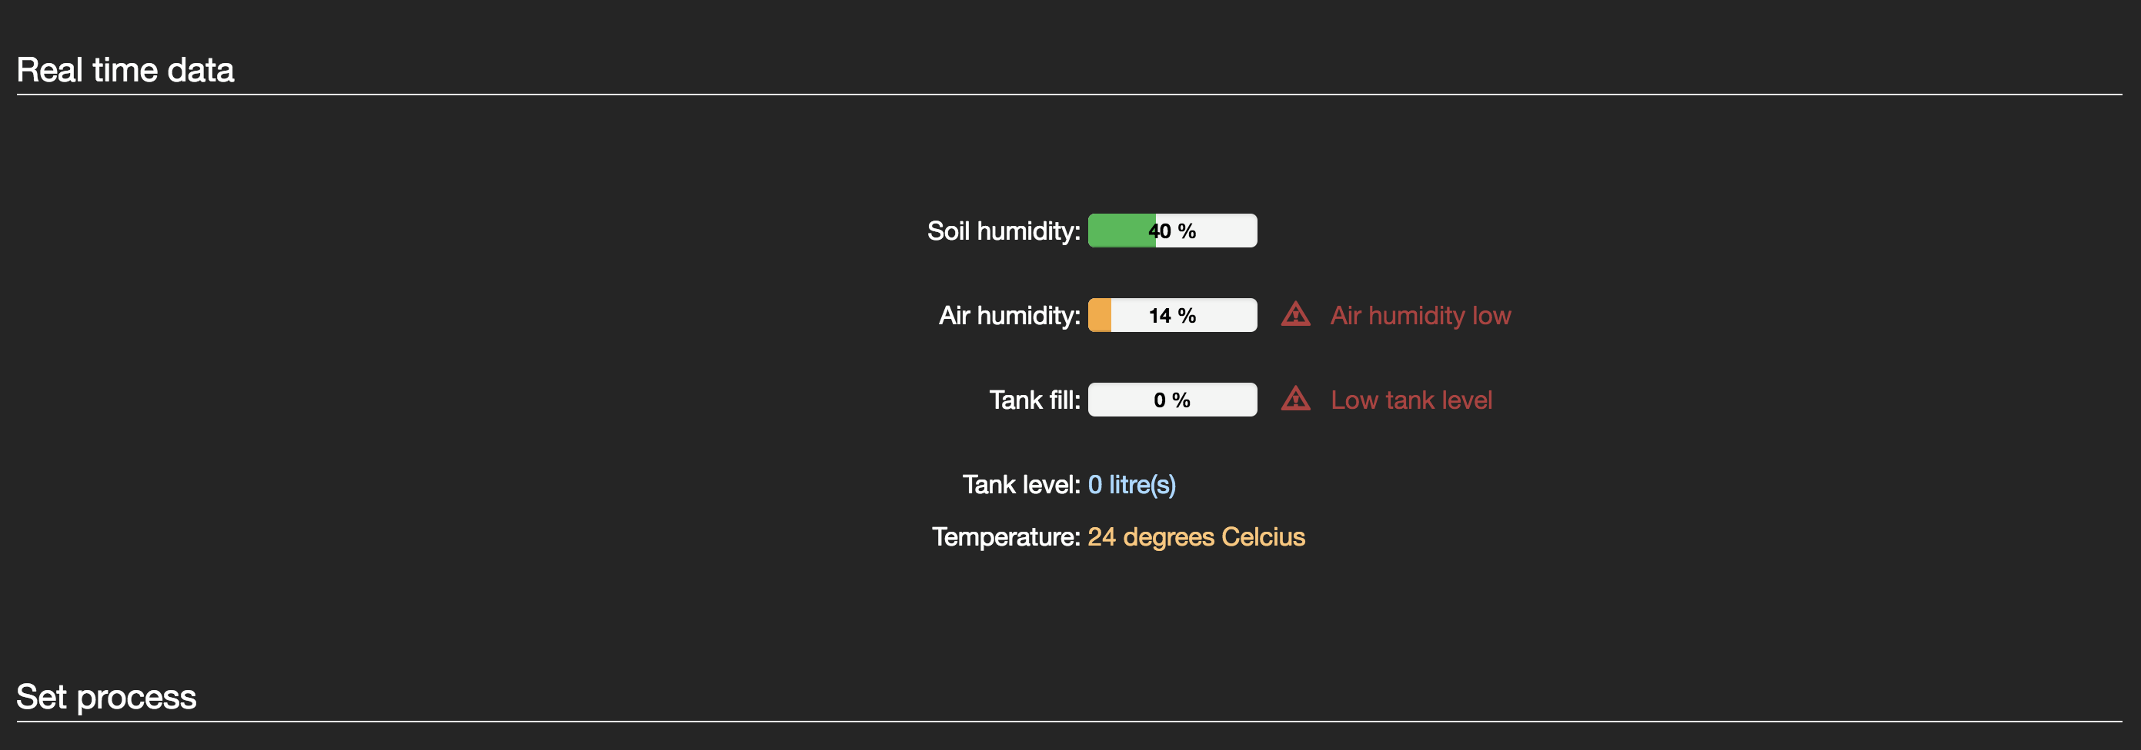

Real time data section **– Contains 5 parameters**

1. **Soil humidity – displays soil humidity in % value.**
2. **Air humidity – displays air humidity in % value.**
3. **Tank fill – displays tank level in % value.**
4. **Tank level – displays tank level in unit of measure (default: litre).**
5. **Temperature – displays temperature in unit of measure (default: Celcius)**

**These parameters cannot be set. They are purely informational and read-only. Their value comes from the Arduino Process described in irrigator_hardware.doc**

**All these parameters have a warning label. The warning level is visible only if the parameter value is under a critical threshold. For example the air humidity is under a threshold of 20% (current value 14% ), therefore a warning is displayed.**



Set process section **– Contains two selectable options**

1. **Auto Irrigation – Select this option to run system in auto mode. You cannot turn on/off the pump while the system is running in auto mode but you can turn system on or off.**
2. **Manual Irrigation – Select this option to turn the pump manually from buttons 3) and 4) (see buttons section). If the process runs in manual mode it won’t process sensor data to turn on the pump automatically.**